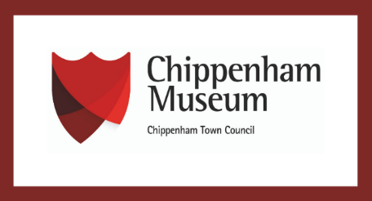



Creative Heritage Project
2024
Evaluation Report
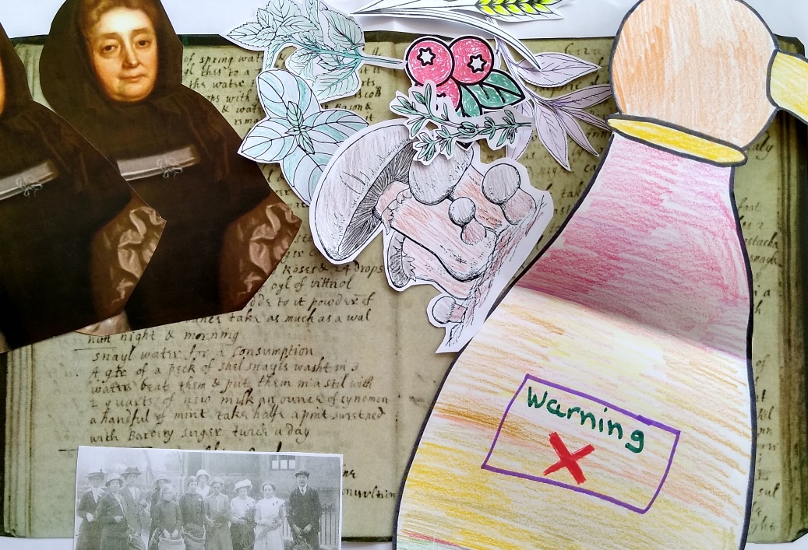

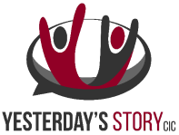
In partnership with


Contents
 | Page
Introduction | 1 -2
Planning | 2-4
Delivery | 4-12
Measuring Impact | 12-15
Conclusion | 15-16
Recommendations | 17
Appendices: | 18-31
Appendix 1 – Session timetable | 18-19
Appendix 2 – Session overview | 20-23
Appendix 3 – Full session plan | 24-27
Appendix 4 – Observation report | 28-29
Appendix 5 – Collaborator's testimonials | 30-31

Introduction
This report is an evaluation of an outreach and community engagement project in collaboration with Doorway, Chippenham Museum, Wiltshire and Swindon History Centre (WSHC) and independent local artists.
The project culminated in an 8-week programme of local history and heritage workshops with an overarching theme of women and wellbeing in Wiltshire.
The goal of the programme was to appeal to a more diverse local usership for WSHC with emphasis on those less socially advantaged, to provide awareness of local heritage resources and encourage the participants’ future interest in the ongoing telling of potentially hidden histories.
Intended outcomes:
- create a rapport and foster a positive relationship with Doorway charitable services for homeless people, or those vulnerable to becoming homeless
- collaborate with project partners to disseminate ideas and findings on forgotten local histories
- have an achievable, informative and positive creative takeaway for the participants
- to raise awareness of Doorway and help promote the organisation’s value to a wider audience
This report will analyse findings to reach a conclusion regarding ways to improve for future endeavours and will provide recommendations for actions to achieve this and encourage future support for similar ventures.

Purpose
This report will provide an overview of the work undertaken for a collaborative local history and heritage project including Wiltshire and Swindon History Centre, Doorway Chippenham, Chippenham Museum, creative practitioner Caroline Rudge and Yesterday’s Story CIC’s Creative Director, Emily Malcolm. An evaluation of the project’s effectiveness and success will follow to identify ways to improve approaches to future similar projects.

Background
At the Wiltshire and Swindon History Centre, outreach and community engagement are key organisational aims. The History Centre’s Local Studies Lead, Julie Davis, produced a proposal for an 8-week programme of local history workshops aimed to provide awareness of Wiltshire Council’s Heritage Service and resources that are available to the public. The objective was to bring local history narratives to an often overlooked or underrepresented potential user group within the local community. The service users and staff at Chippenham’s Doorway charity were chosen as a focus for collaboration. Along with WSHC Archivist, Sophie Johns and Engagement Officer at Chippenham Museum, Elaine Davis, a proposal was presented to Doorway’s Director of Services, Kev Long and questions were asked about whether this sort of initiative would suit the centre’s users and their supervisory staff.

Planning (January-April 2024)
Discussions with Doorway helped to shape the content of the series of workshops to the needs and interests of the regular service users. Aiming the programme to activate interest in Doorway’s newly acquired allotment was suggested, and themes of cultivation, sharing, independence and empowerment were prioritised. The research areas that WSHC and Chippenham Museum appeared to be best suited to Doorway’s Women’s Group and the decision was made to design a programme of workshops under the subject matter of women and wellbeing in local history to appeal to the members of this group.
A meeting with the group’s Facilitator and Doorway Worker, Kerry Bunce, helped to garner ideas as to which teaching and learning styles may be appropriate for the regular attendees of the group. Utilising the expertise of Elaine Davis, an 8 week programme was devised (see Appendix 1 for the session timetable and Appendix 2 for the session overviews).

Doorway service users
Who: Local women who are using charitable services for homeless people, or those vulnerable to becoming homeless.
How: It was established that use of accessible and inclusive language and topics that are relevant to the local area, women and wellbeing would be required. As the Doorway drop-in centre is intended as a place of safety, support and refuge as well as providing information, it was important that the tone and approach of the sessions be welcoming, compassionate and practical.
To develop a sense of trust with the target audience early on it was necessary to establish a reliable structure to the programme and exercise a robust line of communication, but also to maintain a sense of informality. Demonstrating leadership but not authority was the best approach to help put the group members at ease with the project providers.
Where: It was important that all involved knew where to meet, when and what we were going to cover as well as what was expected of them at each of the sessions, and for the overall project. We planned to be realistic about the level of participation that was required to keep the project moving and come to fruition by being clear about the intended outcome: creative output, opportunity for learning about local history and community collaboration. Project staff met with the group at the Doorway drop-in centre during the group’s normal meeting hours of 2-4pm on Mondays.

Doorway staff
It was important that the Doorway staff were confident that the project team were presenting them with a solution to their use of time with their service users and not creating more work or additional costs for them.
The objective was to offer the group a free and tailor-made programme that provided information on local heritage services and the impact that local people have on the longevity of local history and heritage as well as the positive impact that learning about local history can have on wellbeing.

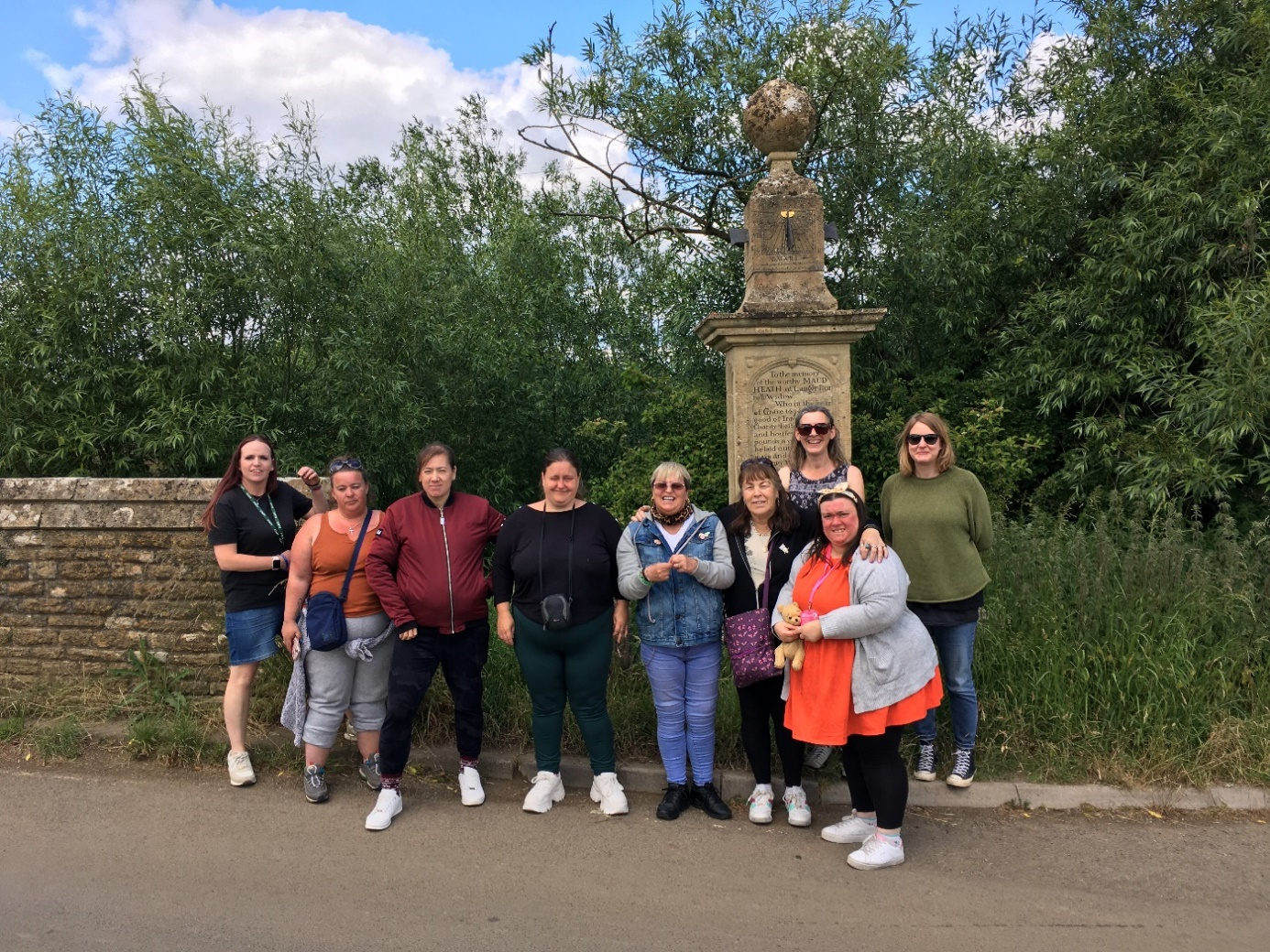
The Doorway group at the Maud Heath monument at Kellaways during their afternoon trip, courtesy of Doorway
“Women’s group have had enjoyable sessions learning a lot more of Chippenham’s history.”
Kerry Bunce, Doorway Women’s Group Facilitator

The project needed to showcase Wiltshire Council’s Heritage Service and resources and meet Chippenham Museum’s outreach remit. It was also important that the group understood that these services were available to the staff and service users of Doorway to access freely as local residents.

Delivery (May to July 2024)
The series programme was divided into weekly 2-hour workshops delivered by Julie, Elaine and Sophie.
Julie’s first meeting with the group attendees enabled her to see how the group wanted to work, to begin to establish a rapport and inform the group of the project proposal. It was identified that the group were used to having time and space to chat and that they would require some support with guiding focus to make each workshop function. Some group members responded better to content and discussion if they had something else to support their focus such as drawing or colouring. The group were enthusiastic about the prospect of an 8-week learning project with a creative output.
This initial meeting enabled the project team to imbed colouring and drawing into session plans and to consider extra time for varying levels of engagement and/or concentration of the daily life priorities of the group members.
Each session was designed to include the telling of a local history narrative using WSHC’s local studies library and archive or items from Chippenham Museum’s collections, relating this to women and wellbeing, resulting in a creative output by the end of the project.
For an example of a full session plan see Appendix 3.
A set of purely creative sessions were organised, with creative practitioner Caroline Rudge attending the first of these to advise on the work that was needed to create a digital animation. A story board was created during the first session and this was used to form the basis of the creative work thereafter, each piece of the story board turning into its own theme. Caroline returned for the final creative session to film the animation.
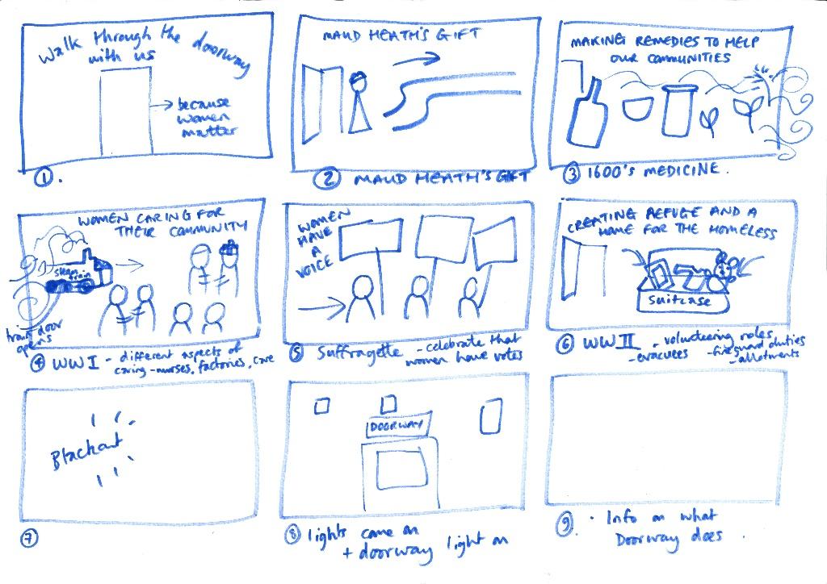
The creative story board
The delivery lead for each session wrote a session plan and discussed an historical story with the help of copies of documents, records and images or objects. Some sessions included a craft element, whereby the group learnt to use macramé with Elaine, some with colouring and sticking and some with drawing and collaging. The creative tasks formed part of the group’s consideration of and reflection on the discussed themes at each session, whether this be developing recipes and home medicines together, plotting maps and drawing monuments or collaging images. It was felt that these creations could also form part of the final creative piece.
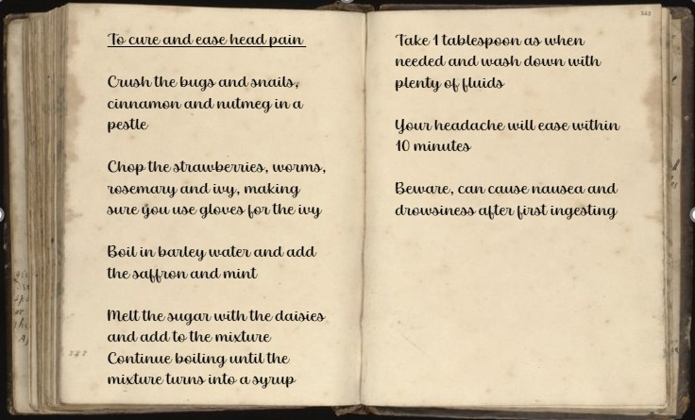
The recipe the group created (above) and filled herbal bottle (below) alongside materials additional used for delivering Session Two:”C17 Healers”
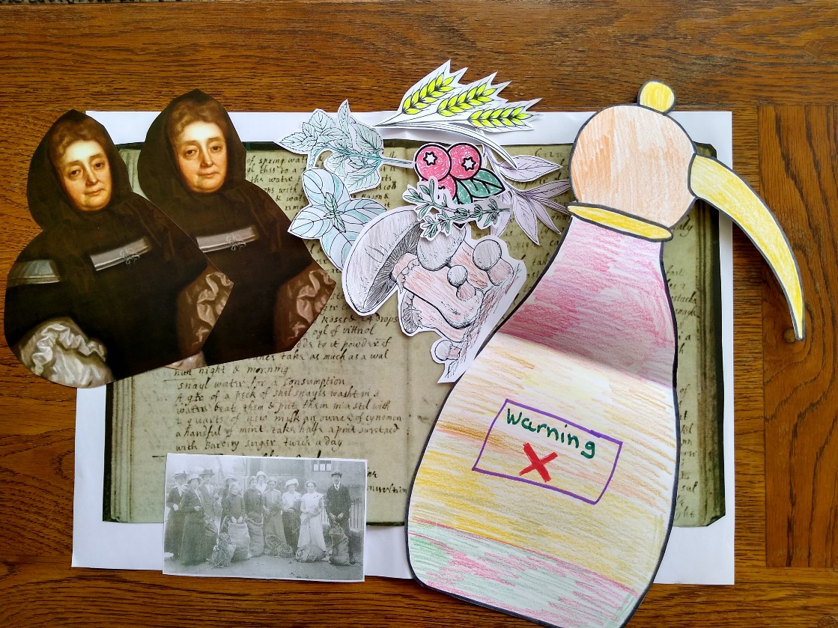

It transpired that, as lead, Julie was required to be flexible with regard to scheduling the proceeding programme due to the varying accessibility needs of the participants. Considerations such as shortening or moving sessions in response to the group members’ availability were done to accommodate the majority. Some of the group showed an interest in seeing Maud Heath’s themselves after the session about her. Kerry arranged for transport, and one session was devoted to a trip out to see the causeway and the Great Somerford allotment, the site which was due to be covered in another session. The trip added another dimension to the group’s learning, and was an enjoyable experience for everyone.
Julie compiled observation reports for each session that she attended, to be used to further inform and improve forthcoming sessions. It must be noted that these reports were written by one individual who had an active interest in the outcome, but they can still provide useful insight. From the reports it can be seen that the group appeared to progress well through the sessions.
“The group members were generous with their conversation and feedback and each session felt very much a shared experience during which we all learned something new about each other and about the history of Wiltshire whenever we met. It was a privilege to see how proud the group members were of what they achieved together, and I am inspired to find out what can be ventured in future collaborations.”
Sophie Johns, Archivist at WSHC
Observation report summary
The group were interested and excited about the project from the word go, and were already working well together, possessing skills such as understanding each other’s strengths, with the ability to support each other with respect and inclusion. It was noticeable that the first couple of learning sessions and the creative sessions were more muddled and less focussed than the others. The reason for this could have been the fact that the group were unsure about what was happening, or that there was less structure to these sessions. This was particularly noticeable during the creative sessions. The group members had wanted to take ownership of a section themselves, but because they were not able to attend every session thereafter it was harder for those who were attending to know what was happening and what to do. Purely focussing on creative work also led to a lack of structure to the sessions. This, coupled with a move away from group working to individual output may have led to a reduction in confidence and proactive participation by group members.
“I have never worked with people who are so enthusiastic to grab an opportunity with both hands and see where it leads, to be open to anything, to enjoy learning about new things, and with such a willingness to share their thoughts and experiences. They are all very special people who I won’t forget, and I hope very much that they enjoyed the project and the connections we made together too.”
Julie Davis, Local Studies Lead at WSHC

It should be noted that the project was only able to fund two creative practitioner sessions. The creative sessions may have been run more smoothly if an experienced creative practitioner had been able to lead them.
The sessions that involved learning with additional elements to support focus and included active breaks where the group were, for instance, playing a game, handling original items or trying on clothing worked best. These sessions were noticeably more relaxed and thus, focussed. In these sessions the group became so engaged they actively voiced disapproval of distractions such as mobile phones going off.
For an example of an observation report see Appendix 4.
“Working with and building such a positive relationship with Doorway has been exceptional. This is a group within its community, that the museum has wanted to connect with. As Doorway’s work is extensive being able to discuss possibilities with staff was invaluable and identifying the Women’s Group as an appropriate starting point meant that everyone involved was able to explore that could be done and see what benefits engaging with heritage can have. It is hoped that this will open up more opportunities to work, not only with the Women’s Group again but with other Doorway users.”
Elaine Davis, Outreach Officer at Chippenham Museum

Working with and building a positive relationship with Doorway and the Women’s Group exceeded expectations. This is a group within its community, that had been considered hard to reach. As Doorway’s work is extensive, being able to discuss possibilities with Doorway staff was invaluable and identifying the Women’s Group as an appropriate starting point meant that everyone involved was able to explore what might be possible and see what benefits could be gained. It is hoped that this will open up more opportunities to work, not only with the Women’s Group again, but with other Doorway users.

The project culminated in a celebratory event at Chippenham Museum. All those who had been involved in the project were invited, along with friends and family of the participants and colleagues from the partner organisations. Julie presented a summary of the project, and everyone watched the completed digital animation that the group had created. A physical display had also been created, containing information that had had been used in the learning sessions alongside examples of the creative work used in the animation. Hot drinks and biscuits were also provided by Chippenham Museum.
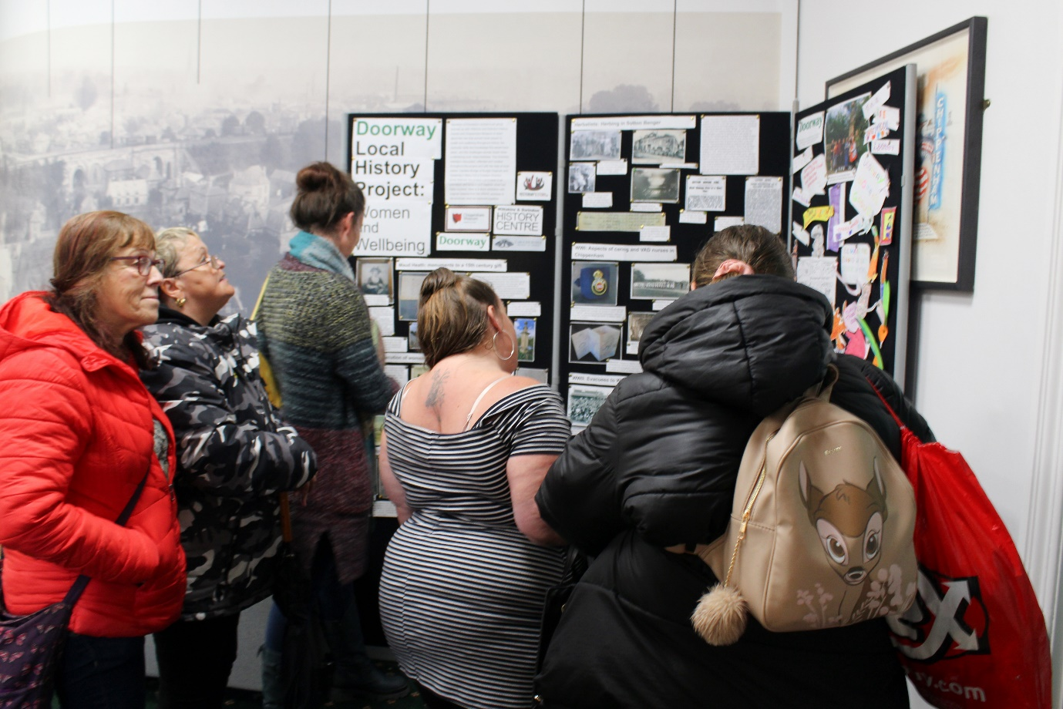
Members of the Doorway Women’s Group viewing the display, photograph courtesy of Gail Foster and Doorway
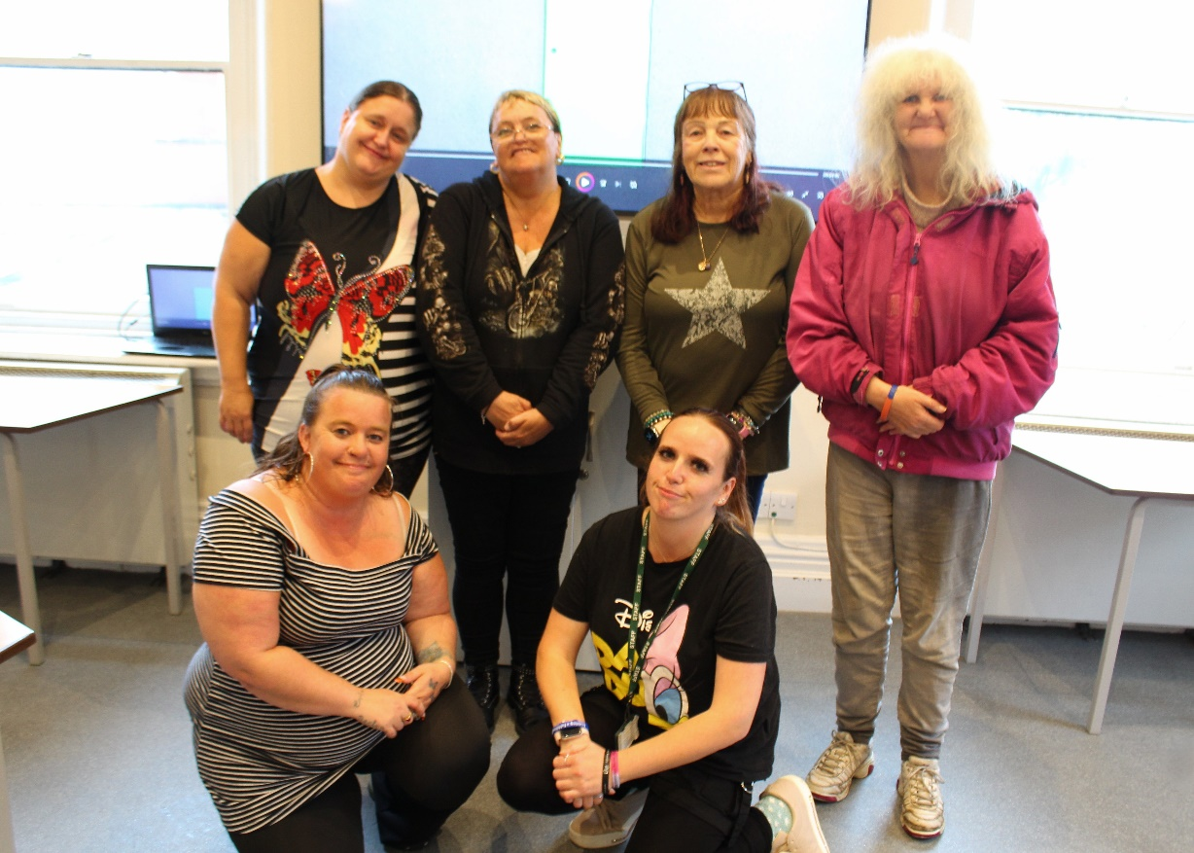
Kerry and members of the Doorway group attending the celebratory event in front of their creative animation, photograph courtesy of Gail Foster and Doorway
It was clear that the project participants enjoyed the event which highlighted the work they did and shone a light on their skills and qualities. Their pride in what they had achieved was self-evident, as was the enjoyment they gained from seeing others congratulating them and viewing their work and themselves in a positive light.
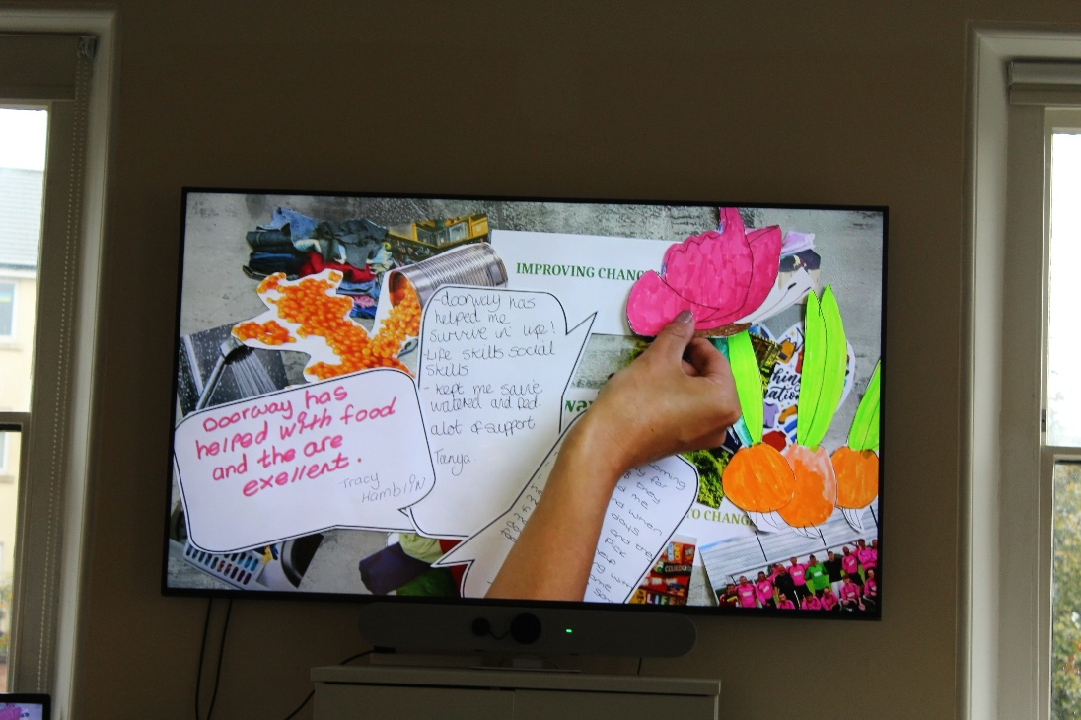
Scene from the animation at the celebratory event, photograph courtesy of
Gail Foster and Doorway

The display remained at Chippenham Museum for a number of weeks before moving on to Chippenham Library. A QR code was created and added to the display to enable people to view the creative animation via You Tube.
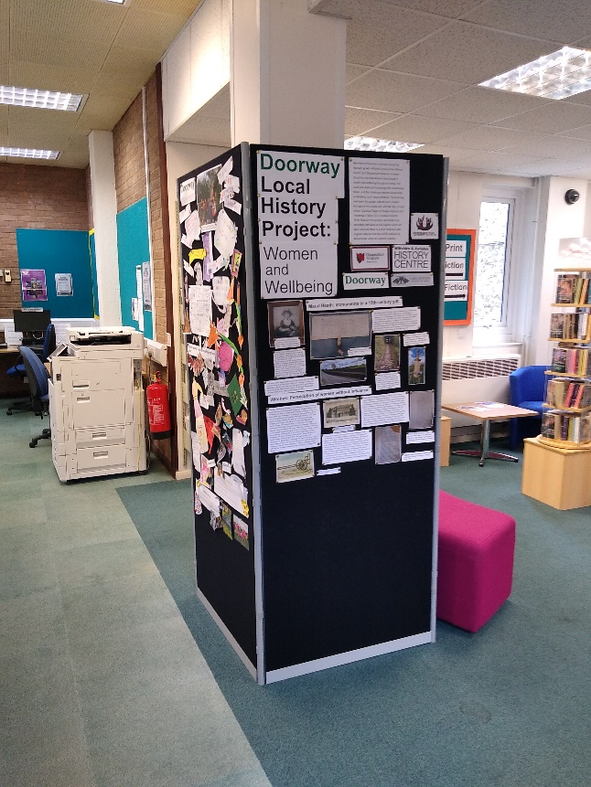
What Happened
“Learning something new finding about family history”
Feedback from project attendee about the ‘best part of the project’

What worked well:
- The participants in the workshops seemed to enjoy the sessions that involved visual, verbal and active explanations, showing artifacts and pictures with the opportunity to try on costume as well as having something to listen to whilst attending to tactile tasks like making or drawing. The ability to choose between a number of interaction styles helped aid focus and manage energy levels, enabling each member of the group to get the most of out the sessions by choosing the options that worked best for them.
- Making the project collaborative between varying educational concerns (i.e. Local studies, Archives and Museums) made planning more difficult due to different workloads and priorities, but made the outcomes more varied, resulting in a higher likelihood of the individual participants finding some meaning in sessions. On a practical level, this approach also spread the time, materials, money, energy and investment away from one organisation only. Using this approach, the project was able to achieve much more together than alone.
- Having time out in the sessions for the members to release some social energy and discuss unrelated and personal issues seemed to keep them encouraged to come back to sessions.

- Having an excursion at the end of the sessions to put the content of sessions into physical and three-dimensional context increased interest and positivity in the content and subject matter, whilst offering the participant’s time together in the fresh air.
- Similarly, having a tour of the WSHC helped the participants to put who the project staff were and what they did into perspective, and to physically familiarise them with the space in case they were interested to come back to read, research or volunteer.

- Marking the end of the project with a celebratory event offered a chance to reflect and produced a sense of pride in what had been achieved.
“Lost without it but feelings of success!”
Feedback from attendee about feelings at the end of the project

What worked less well:
- Trying to fit too much content into sessions served to tire out the participants, curtailing their enthusiasm and ability to concentrate and engage, and did not allow for sufficient delivery of work that had already had time invested in it.
- The participants were available on a casual and personal basis only and so came and went as the weeks went on. The programme was designed to accommodate this but in order to rely on returning interest more time may have been spent getting to know the members of the group so that they felt inclined to come back and work towards a more solidly explained and understood end goal (both within each session and at the end of the whole programme).
- The final animation session did not do enough to engage the imaginations and hands-on capabilities of the group members, and it mostly ended up being done by the group leaders so that something got finished in the allotted time.
- Similarly, the leaders and deliverers could have had a better comprehension of what the end objective was and how each leader and deliverer would individually work towards this and how the participants would benefit from the programme. This may have been helped with more structured orienteering sessions with participants prior to the start of the teaching programme.

Measuring Impact
Participant responses:
- Participants were verbally incredibly positive all the way through. However, at the end session only five evaluation sheets were filled in. This is due to a number of issues including: not all participants being present at the last session, not all participants being confident to write and express their feelings on paper and the timing of the handing out of evaluation sheets. It may have benefitted from being done in a more controlled and assertive manner.

- Only 4 participants of a possible 7 responded and one volunteer worker for Doorway (for whom the form was not intended). The feedback form from the volunteer has been disqualified in this report for clarity.
Results:
By way of an overview, all participants answered “yes” to the following closed questions:
- Would you like to take part in another project with the Wiltshire & Swindon History Centre and Chippenham Museum?
- Would you recommend this project to others?
This is an overall positive and successful response to the project. For perspective: each session had between 7 and 2 participants and at the end of the programme there were 5 participants and 4 responders to the evaluation form we handed out.
To the question:
- During the project have you practised any of these skills?
The number of participants who circled each option:
4 out of 4 listening skills
3 out of 4 focussing skills
3 out of 4 understanding skills
3 out of 4 working as a team
3 out of 4 discussing
2 out of 4 thinking differently.
The average data posits that a majority of the overall attendees at sessions were practising positive engagement skills in one or more of the workshops. The positive emphasis here being that all participants felt that they practiced “listening skills” which are essential in some of the key themes that the project intended to explore of compassion, empathy and sharing. However, only half the participants expressed “thinking differently” which does not quite align with this theory. This may have been too indistinct a question to interpret.
The next question was:
- Do you think that taking part in the project has helped you feel …?
The number of participants who circled each option:
2 out of 4 less anxious
2 out of 4 increased togetherness
4 out of 4 discovered a new interest
1 out of 4 more confident
1 out of 4 more enthusiastic
4 out 4 enjoyment in something new
2 out of 4 improvement in overall wellbeing.
The average data posits that the majority of the overall attendees at sessions were feeling positive emotions and sensations in one or more of the workshops. The positive emphasis being that all participants noted they “discovered a new interest” and felt “enjoyment in something new” which speaks to the success of the focus, breadth and broader subject matter and content of the workshop sessions.
The standout response here is that only 1 member felt “more enthusiastic” and that only 1 felt that it made them “feel more confident”. This outcome may have been different if opportunities had been created early on to explore the individuality and identity of each participant and potentially inspiring a sense of togetherness to put more of them at ease.
To the qualitative question on the evaluation sheet:
- “Is there anything that could have been done better?”
4 out of 4 said “no”.
This does not posit any useful data apart from that the participants could not think of a way in which the programme of workshops might have been improved so the question perhaps needs to be more directive, for example: “if you could add, change or improve the sessions how would you do it?” or “what would you like to see more or less of if you were to participate again?” so that there is some feedback to evaluate.
To the question:
- “What has been the best thing about the project?”
4 out of 4 responded, and their responses were as follows:
“Learning something new finding out about family history”
“Coming together making a project enjoyed every week”
“Very interesting and enjoying as a team”
“The best thing about coming here was meeting [the session leader]”
These are positive responses with a theme of teamwork and learning. These are outcomes that the project aimed to achieve, and it is useful feedback. For more varied and detailed response, the questions will need to be more directional and encouraging.
To the question:
- “How do you feel about the project coming to an end?
4 out of 4 responded and their responses are as follows:
“Sad”
“I feel sad it came to an end”
“Lost without it but feelings of success!”
“Sad as we won’t be seeing everyone weekly”
These have a common message that the participants did not want the sessions to end but due to the open ended nature of the question it is hard to discern what we can take from this by way of evaluation data as they do not respond to content, structure or delivery just that they enjoyed it as much as to being unhappy that it ended. We do not know why they feel this way in most cases however the responses that noted “feelings of success” and “sad as we won’t see everyone weekly” suggests a sense of achievement and enjoyment of the group dynamic.

Conclusion
What has been invested:
- Involvement of the staff and leadership at the drop-in centre for Doorway, their organisation of the groups and members, mini-bus hiring, stationary resources and projector.
- Time and efforts of the service users and group participants
- WSHC staff time plus printing and some budgetary resources, use of Education Room for workshop session and tour, archival and bibliographical resources.
- Chippenham Museum staff time, resources and some budgetary resources including refreshments, macrame resources and a herb for each participant, plus the use of education room for the celebratory event.
- Private artist’s paid time and resources to complete the animation.
- Yesterday’s Story staff time and printing resources.

What has been delivered:
- An 8-week series of workshops on local history and heritage.
- Successful engagement with Doorway Women’s Group.
- Creation of an animation based on the project sessions, plus macrame skills and a piece to take away along with a herb to grow.
- Interaction with items from WSHC and Chippenham Museum’s collections.
- Imparted expert information and demonstrated what is on offer to the group as part of the local community (allotments, history centre, museum, historical monuments)
What outcomes have been achieved:
- Delivered a collaborative project directed towards part of the local community that had previously been overlooked.
- The group had a day out in the local countryside looking at the Maud Heath causeway, public allotments, a tour of the WSHC, a visit to Chippenham Museum, created and crafted pieces of their own art and learned something new.
- The group were provided with allotted time to practice mindful listening and discussion.
- Creative response from the group that culminated in a private showing alongside an exhibition of their work at Chippenham Museum and Chippenham Library.
- Collaborated with local artists and heritage practitioners to bring the project together.
- As an investigative project to pose an example to other stakeholders of what can be done with little to no financial budget, but with successful networking.
- Justification that there are people in many varying circumstances who need and are interested in heritage resources, and should be considered as a valuable targeted customer base in the future.

What requires improvement:
- Planning for time to get to know the participants and customise the workshop approaches to their particular needs.
- Preparing all delivery leaders and collaborators for the sort of experience they are likely to have with the groups and how much time they will have to complete their work.
- The evaluative tools: use of surveys, questionnaires and feedback forms need review and more time encouraging hands-on investment from the participants to make sure they are contributing to the creative outcome (i.e. animation, exhibition).
For all collaborator’s testimonials see Appendix 5

Recommendations
- Planning - More planning that involves time spent getting to know the group members/service users and generating a rapport to understand better the individual needs and approaches to learning and creating with a focus on structure, active breaks and focus support aids.
- Contribution - Ensure all collaborators have a full understanding and demonstrate informed willingness to participate in the project before it begins in earnest. This would require creating the content, structure and methodology in advance of requesting other people’s involvement.
- Evaluation - Improve the line of questioning for the evaluation sheets to garner as much information for review as possible and to create more time and space for the participants to complete this. The questions do not need to be leading but to offer potential ideas for how to encourage more analytical answers.
- Methodology - Build a teaching/coaching methodology that encourages confidence, lateral thinking and enthusiasm in participants to guide more robust results and outcomes from their involvement.
- Coaching - Spend more time coaching the participants in how to conduct their own research using heritage resources as a way of achieving the original objective for the project to raise awareness and generate inclusive usership. Reinforcing the awareness that the resources are not only for specialists, academics and researchers but are broad and relevant to local people whatever their circumstances.

Report by Sophie Johns
2024

Appendix 1
Doorway Women’s Project
Session Timetable
Project topic: Women and their role in health and wellbeing

26/3 - Julie to introduce WSHC

8/4 - Elaine to introduce Chippenham Museum – Julie and Sophie to introduce the project

Session Themes:

- Caring Women – Maud Heath Story (C15) - Sophie 15/4

- Healers – C17/C18 – Julie 22/4

- Witches – C17/C18 – Julie 29/4

- WWI – VAD nurses in Chippenham – Elaine 13/5

- Commercialisation of herbing (Sutton Benger) – Elaine 20/5

- WWII – Collecting fruits and herbs for the war effort – Julie 3/6

- Great Somerford: the beginnings of the allotment movement – Sophie 10/6

- Creative session – planning and creating animation pieces 17/6

- Creative session – creating animation pieces 24/6 1/7

- Creative session – creating animation pieces 1/7

- 1x Animation session with creative practitioner Caroline Rudge 8/7

If the group are in agreement, the animation and creative works will be used as part of an exhibition which will also promote Doorway the work they do to help the people of Chippenham improve their health and wellbeing.

Finished work could be shown at:

Doorway
Chippenham Museum
Wiltshire & Swindon History Centre
Wiltshire Libraries (?)

Saturday 7 September
The Maud Heath Centre celebratory event

Saturday 14 September
The Yelde Hall – Maud Heath event

Maud Heath and Beyond: Exploring the Lives of Women Before 1600
Study day at The Wiltshire and Swindon History Centre
21 September

Appendix 2
Doorway Project
Women’s Group, Mondays 2-4pm

Project topic: Women and their role in health and wellbeing

26/3 - Julie to introduce WSHC
8/4 - Elaine to introduce Chippenham Museum – Julie and Sophie to introduce the project

Themes:

- Caring Women – Maud Heath Story (C15) - Sophie 15/4
3448/1/1 - Maud Heath Trust – original trust deed of 1474
Book - Dry Shod to Chippenham by Kay Taylor, 2012. Ref. CHP.381
3448/4/4 - Article on Maud Heath, 1913
P14168 - Photograph of the causeway, early 20th century
Photograph of C19 print depicting Maud Heath – by Robert Bowyer, 1806, from the Historic Gallery, Pall Mall, London
Macrame - Learn 2 basic knots to start to make a key ring

- Healers – C17/C18 – Julie 22/4
Doctress Neil advert
Herbalist – Elizabeth Freke (1531A/3/3) - An Account of the Freke family history by Elizabeth Freke, 1671-1692
Johanna St. John
Ann Colborne

Macrame - Learn a 3rd knot to complete the key ring to take home

- Witches – C17/C18 – Julie 29/4
P19820 - etching, ducking stool dated 1668, Wootton Bassett, Wiltshire, printed 1853 (no image available)
Seend witch article, C18
Blog – Sarah Gibson
P51435 - photograph, crowd watching the ducking stool, Aldbourne Fete, Aldbourne, Wiltshire, 1969
D1/39/2/7/f90v – witchcraft accusation – are you able to read this Sophie?!
P3/P/3578 – Ellizabeth Peacock will and inventory
A11/10/1613M - Margaret Pilton of Warminster

- WWI – VAD nurses in Chippenham – Elaine 13/5
Macrame - Use the learnt knots to start a string bag - This could link to the importance of health food fruit veg and this will link to the VADs and I can draw out the story of the VAD cook

- Commercialisation of herbing – Sutton Benger example – Elaine 20/5
Heath, Nesta J. Life and herbing in Sutton Benger : memories of a Wiltshire village, Ref. SUB.949 - herbs to use: feverfew, lavender, sage? – case study – Nanny Ecclestone
P6048 – photo of fire at herb stores in Sutton Benger, c. 1920-30
School Log book – 1917 – there might be information about Nanny’s work with the schoolchildren
Staff records?
Wiltshire Times article, Sat 24 Nov 1917 – Sutton Benger Herb Gatherer’s Social Outing

- WWII – collecting fruits and herbs for the war effort and what they were used for – Julie 3/6
School log books – Ivy Lane SLB Nov 1940 re. Visit by horticulturist F8/500/65/4/1
Edith Olivier words on string bags in ‘Night thoughts of a country landlady : being the specific experiences of Miss Emma Nightingale in time of war’, 1943, Ref. XOL.824 (AL copy available)
WI scrapbook entry – the game of guessing the smell of the herb - in ‘The Social Half-Hour Handbook, 1948’ in 1296/9 ; WI gathering instructions 1815/39 ; MoA Allotment and Garden Guide looking at herbs F8/760/17/10 ; Broughton Gifford WI collecting parsley 4257/30 ; WT article 5/8/1944 re. Wiltshire Herbs Committee ; MoA advert in Wilts Times 3/9/1942 ; SLB Bromham School – F8/500/42/1/2 (9 and 15 Sep 1941 entries re. Blackberries and mulberries) ; Ministry of Agriculture 1941/2 and 1943 – campaigns re. Women are more than able to help G13/132/61 and leaflet with a man’s boot on it re. Ministry of Information’s idea of the role of women (same ref).
Macrame - Finish string bag – again a good link to the collecting of fruit – the bag would be a take home and therefore an encouragement to use as a sustainable alternative to the plastic bag.

Macrame - Pot up herbs and start a plant hanger

- Great Somerford and the beginnings of the allotment movement – Sophie & Julie 10/6

Macrame - Finish the plant hanger – Can also be linked with allotments and is again a take home …. This and the string bag could also be linked to encouraging healthy eating?

3x Creative sessions – planning and creating animation pieces 17/6, 24/6 and 1/7
Create material to use for a film animation

1x Animation session with creative practitioner Caroline Rudge 8/7

If the group are in agreement, the animation and creative works will be used as part of an exhibition which will also promote Doorway the work they do to help the people of Chippenham improve their health and wellbeing.

The group will visit Chippenham Museum either during or after the running of the project, and the aim will be to encourage the group to also visit WSHC if and when they feel comfortable.
It is hoped that if the group like this idea, they can get involved in the Maud Heath project which starts in May – invitations to all the events...

Finished work could be shown at:

Doorway
Chippenham Museum
Wiltshire & Swindon History Centre
Chippenham Library

Saturday 7 September
The Maud Heath Centre celebratory event

Saturday 14 September
The Yelde Hall – Maud Heath event

Maud Heath and Beyond: Exploring the Lives of Women Before 1600
Study day at The Wiltshire and Swindon History Centre
21 September

A preview event to be held at either WSHC or Chippenham Museum, inviting people from Wiltshire Council and the community such as the Public Health team, the team who work to help the homeless at Wiltshire Council, local councillors, local press and others. It will be an opportunity for Doorway to tell more people about the work they do, and an opportunity for some of the women’s group members to talk if they would like to.

Appendix 3
Doorway Creative Heritage Project
Session Plan
2024
COURSE TITLE: The role of women in health and wellbeing from 1300 to the present day | COURSE CODE: WSHC | DATE: 15/4/2024 | SESSION NO: One – Maud Heath
TUTORS: Sophie Johns |  | TIMING: 2-4pm | NO OF LEARNERS: 6
VENUE: Doorway, The Citadel, Bath Road, Chippenham |  | EQUALITY AND DIVERSITY: Group guidelines created to ensure everyone feels safe, valued and respected regardless of gender, age, race, sexual orientation or any disabilities. Assessment of any additional needs so that they can be addressed.
SESSION PLAN
SESSION AIMS: To tell the story of Maud Heath as an introduction to the history of women, work and wellbeing in local space and place. To facilitate discussions which encourage the group members to respond to the story in relation to how they identify with the local area. Give guidance on the resources that are available to them to help them learn more (Libraries, Archive and Museum). Moving towards a period of creative reflection, learning and using macrame skills. Forming a visual reminder of what they have learnt/created.
LEARNING OBJECTIVE: (WHAT WILL THEY BE LEARNING AND WHY?)
- History of local women: Considering how the history of women is formed by archival fragments between which gaps are filled by oral history and tradition. What these fragments look like in practice: monuments, documents, objects.
- Libraries, Archives, Museums: How these artefacts are found, kept and made accessible for the public – how can you take ownership of your local history and situate yourselves within it.
- Creative outlet: Drawing and colouring, creating a map of the historical story on the local area. Learning how to create a macrame knot pattern – reflecting on how Muad made her own legacy for the wellbeing of others in the future (planting ideas of crafting, growing and saving to aid and assist others).
SUCCESS CRITERIA: (HOW WILL THEY KNOW THAT THEY HAVE BEEN SUCCESSFUL IN MEETING THE LO?)
- Have had a conversation where (ideally) everyone feels comfortable and confident to join in.
- Have learned a practical skill – using local resources for interest/research/history
- Have learned a creative skill – tying macrame knots to make something.
RESOURCES:
1. Projector, laptop and cables: PowerPoint showing images of archive, monuments, records and legacies (plaques, statues and documents).
2. Art or creative supplies: pencils and paper, colouring pencils, scissors, glue, map print, macrame twine, tape and key rings.
3. Books: Maud Heath and local pamphlets/other information.

KEY SKILLS: listen, create, participate, reflect.

TIMING | CONTENT/TOPIC/ACTIVITY | TEACHING AND LEARNING METHOD | LEARNING AIDS/RESOURCES  Including differentiation and use of ICT | ASSESSMENT OPPORTUNITIES (RARPAP) LINK TO SUCCESS CRITERIA | HEALTH AND SAFETY IMPLICATIONS
2pm | Welcome to the session from Sophie and introduction to the session content |  |  |  | E-safety, Safeguarding and GDPR included in induction
2.10pm | What’s the story of Maud Heath? A short story telling of what we know and what we don’t know and why. Have you heard this story? What have you heard? | Deliver story using visual aids and questions to group to reflect and discuss – C19 image of Maud | PowerPoint | Start a conversation
2.20pm | Where is the evidence? Images of what remains and serves as the bones of the story – monuments, causeway, documents and how the legend fits in. What do you glean from these objects? Who was Maud and what does the story impart to us? | Deliver story using visual aids and questions to group to reflect and discuss | PowerPoint | Facilitate reflection, listening skills
2.30pm | Where did the causeway run? How would the causeway have helped people? What is the landscape like in this area; why was a causeway needed? | Introduce an enlarged map of Chippenham and the area north of it and show where the route runs. Encourage the group to draw the route on the map. | Pen and paper | Respond creatively
2.45pm | What is left of the causeway now? | Show photographs of parts of the route – introduce artworks depicting the shape of surviving evidence about the history of the causeway for the group to colour in, cut out and stick to the map | Colouring pencils and paper | Respond creatively
3.10pm | Discussion – what might people have been taking to market along this route? If you were in the position to give some money for the good of Chippenham, what would you use it for? | Take place during the colouring session |  | Understand, Participate
3.20pm | Creative session – how to make a macrame keyring – learn two basic knots. Elaine | Watch teacher, follow pattern, practice? | Macrame twine/string and key ring | Learn creative skill
4pm | End

SESSION EVALUATION (TO BE COMPLETED BY TUTOR AFTER SESSION ENDS)
Prompts:
- Were the personal learning objectives of the session met?
- Were your choices of teaching methods appropriate to facilitate learning in groups, learning for individuals and through their own experience?
- How did the resources used in the session support learning?
- Were the forms of assessment used valid and reliable to check the learning of individuals and the group?
- If you were to deliver this session again, how would you change / adapt / would you need to?

Reviewer

Appendix 4
Doorway project observational report
Session Two 15/4/2024, 2.30-3.45pm
Maud Heath
Presenter: Sophie Johns, WSHC
Observer: Julie Davis, WSHC
Also present: Elaine Davis, Chippenham Museum
Women’s Group Leader: Kerry Bunce, Doorway
Participants: 6

Sophie began by introducing Maud Heath and her story. The group were shown a number of slides with images of various documents on them relating to Maud from the 15th century to the 19th century. She explained that the evidence we have from these items show that Maud left some money, but didn’t specify what for. The causeway was mentioned in the C17, and this is the time period when trustees holding the money used at least some of the money to begin building works. The group were invited to draw the route on a copy of a late 1950s OS map; one attendee enjoyed doing this and there was a mood of interest and excitement as the group chatted about the route.

Julie explained about the marshy conditions, flooding, and what would it have been like to cope with that all those years ago? And what might people have wanted to take to market then? Ideas included fish, chickens and eggs…
Sophie continued with the presentation and showed the group some photographs from the route. She had walked part of it previously, and explained how it and the story meant a lot to local people. The photographs she had taken included the road, causeway and what was left of the oldest section of the pavement. The group looked at images of some of the other parts of the route; the dedication stones and monuments. Sophie had drawn some depictions of these which the group coloured in, cut out and added to the map.
The group considered what the paving was made of and where the stone might have come from; one suggestion was Bath stone, and Julie noted that this tied in with the fossils Elaine showed the group the week before.
Julie mentioned that the Maud Heath project was running some events and one was going to be walking the route. Some of the group were interested in going to see part of the causeway. Julie will look into this.
Julie asked the group – if there was a Maud Heath today who was giving money for the benefit of people in and around Chippenham, what would they like it to be used for? Suggestions included improving footpaths and cycle routes to make them safer and less likely to flood, providing power points for re-charging wheelchairs and making places more accessible.
Elaine introduced the group to Macrame. Everyone took part except one attendee who only had the use of one arm following a stroke and preferred not to take part. Everyone successfully made a keyring and seemed pleased with their efforts.
The group engaged with the session with interest and maintained this throughout. They seemed relaxed and happy to take part; appearing to find the topic and discussion interesting. None of the group were interested in their mobile phones in this session, with only a couple engaging with them briefly. Two participants were chatting towards the end of the session about anxiety – one participant’s anxiety had been high recently, and the other remarked that she had been feeling very anxious recently but felt much better at that moment.
The atmosphere felt relaxed and everyone chatted about other topics such as sharing details about their dogs whilst completing the colouring and macrame too.

Appendix 5
Kerry Bunce:
“Women’s group have had enjoyable sessions learning a lot more of Chippenham history.”
Julie Davis:
“I was unsure if the project would work but was so pleased when the Doorway team decided to take a chance on us. Elaine, Sophie and I were welcomed by the group from day one. Every member of the group is fantastic – I have never worked with people who are so enthusiastic to grab an opportunity with both hands and see where it leads, to be open to anything, to enjoy learning about new things, and with such a willingness to share their thoughts and experiences. They are all very special people who I won’t forget, and I hope very much that they enjoyed the project and the connections we made together too.”

Sophie Johns:
“The people of Doorway were welcoming, enthusiastic and committed to experimenting and learning with us on this project. The group members were generous with their conversation and feedback and each session felt very much a shared experience during which we all learned something new about each other and about the history of Wiltshire whenever we met. It was a privilege to see how proud the group members were of what they achieved together, and I am inspired to find out what can be ventured in future collaborations. Thanks are due to all the dedicated collaborators for their contributions and especially to Julie Davis for her significant leadership and management of this project.”

Elaine Davis:
“The Doorway project has provided a great opportunity for Chippenham Museum to explore collaborative working and the potential of partnership projects with the Wiltshire and Swindon History Centre. It has shown how the bringing together of information held by both the WSHC and the museum can allow engaging projects to be formed.

Developing and delivering sessions with skilled colleagues has allowed for peer learning and sharing. The experience of this will help to shape how the museums Engagement Officer considers integrating objects and documents when developing workshops and presentations in the future.

Working with and building such a positive relationship with Doorway has been exceptional. This is a group within its community, that the museum has wanted to connect with. As Doorway’s work is extensive being able to discuss possibilities with staff was invaluable and identifying the Women’s Group as an appropriate starting point meant that everyone involved was able to explore what could be done and see what benefits engaging with heritage can have. It is hoped that this will open up more opportunities to work, not only with the Women’s Group again but with other Doorway users.

The museum recognises and is very grateful to Julie Davis, Archives & Local Studies Lead WSHC who managed the project. Her drive and organisation ensured that the project was deliverable and was essential to its success.

Chippenham Museum hope that the development of other collaborative projects with the Wiltshire and Swindon History Centre can be explored soon.”

